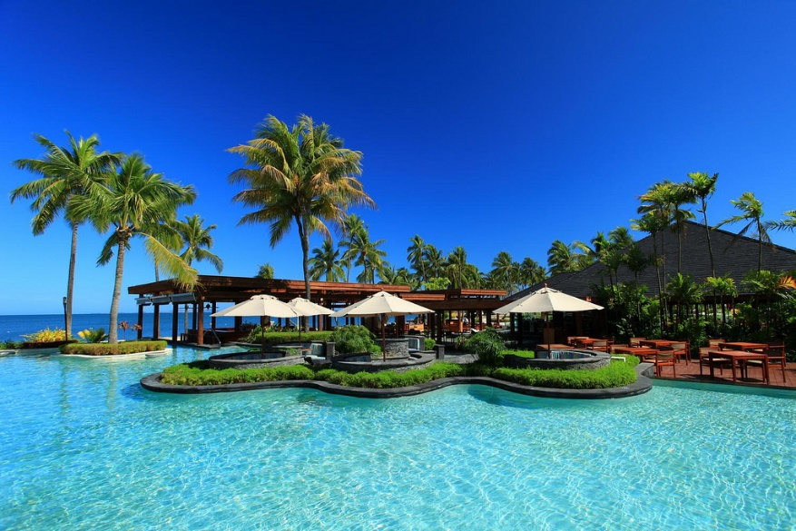
05-08 December
2022
Denarau Island, Fiji

Important Dates
August 31, 2022
Full Paper Submission

September 30, 2022
Notification of acceptance

Call for Special Sessions
(First Page)
Special Session
On
Title of the Special session (this is a template)

Organized by
Organizer One Name , Affiliation, Email
Organizer Two Name , Affiliation, Email
Organizer Three Name , Affiliation, Email
Organizer Four Name , Affiliation, Email

Call for Papers for Special Session

A short abstract describing the covered specific topic (not more than 300 words). This abstract needs to cover the answer of the question: Why do you believe that the proposal is a significant and interesting subject? (You should respect this format)

Topics of interest include, but are not limited to:
- A list of special areas related to the special session, not more than 12.

Technical sponsors (if any):

(Other Pages)

Short biography of the Special session Organizers (photo, name, email, and short biography of the organizer)

Potential Contributing Authors (names and emails):
Names with email and affiliation address not less than 10 (twenty) from at least two countries.

