

WRITE THE TITLE OF YOUR DIGEST HERE
ABSTRACT
Please note that this is a blind review and do not include author name(s), affiliation(s) or contact details below the title. This document serves as a template for preparing a digest for submission to the 7th IEEE Southern Power Electronics Conference (SPEC). Digest submission deadline is 30th June 2022. More information on digest submission can be found in the conference website (http://www.spec-ieee.org/). Your digest will be peer reviewed and the notification of acceptance will be issued by 1st September 2022. If your digest is accepted, you will be invited to submit the full paper by 20th October 2022. Template for the full paper is available at the IEEE conferences website https://www.ieee.org/conferences/publishing/templates.html. Please limit this abstract section to 200 words.

INTRODUCTION
The purpose of the digest is to present your work, as a short version of your intended full paper, to facilitate quick and easy review. Therefore, in your digest, clearly highlight the problem that you are going to address, your contribution, how it differs from the existing literature and solutions, major results that have obtained and their significance. The main body of your digest, starting with the ABSTRACT and ending with the CONCLUSIONS, should be limited to FIVE pages. The REFERENCE section of your digest will not be counted towards the number pages. Use, at least, 10 pt font (12 pt is preferred) in double-space, single column with 1” margins. Do not write anything on the header or footer sections. Do not insert page numbers in the header or the footer. Please do not submit a full length, single-spaced paper that is simply cropped down to five pages.

FIRST SECTION
Enter text, equations, and figures of your first full section here. Inserting figure(s) into a drawing canvas is recommended. See Fig. 1 for a sample figure. You are not expected to follow the exact format given in this document, but the SPEC Technical Committee prefers this format.
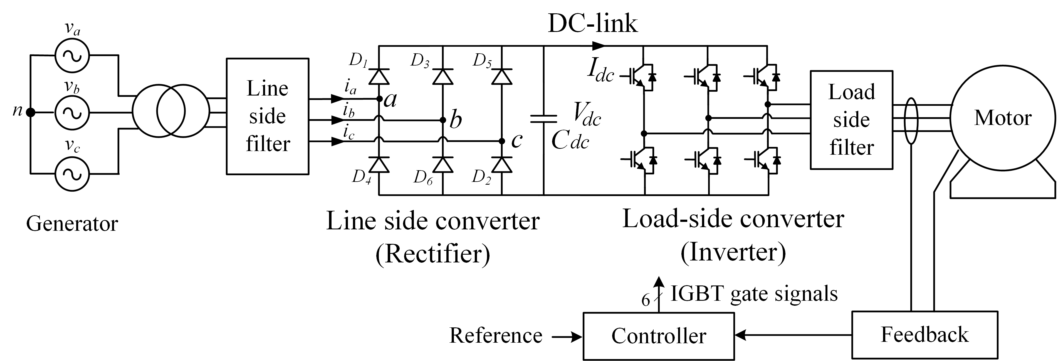
Figure 1: Variable speed drive.

SECOND SECTION
Enter text, equations, and figures for your second full section here. Repeat the same style as necessary for other sections. Equations should be expressed in the following format:
${\text{ax}}^{2}+\text{bx}+c=0$
$x=\frac{−b±\sqrt{b^{2}−4\text{ac}}}{2a}$ (2)

CONCLUSIONS AND FUTURE WORK
State your conclusions here and your plans for the final submission of a full paper, assuming your digest is accepted. Based on the evidence given in the digest, reviewers will asses your ability to complete any remaining work before the full paper submission deadline. Inclusion of experimental work is highly appreciated by SPEC reviewers instead of promising to include future experimental work. This is the last section of the five-page-limit. References are not counted towards the page limit.

REFERENCES
{This section may cause you to exceed the five-page limit. References can be single-spaced. Minimum font size is 10 pt. Use the IEEE referencing style.}

- R. P. Twiname, D. J. Thrimawithana, U. K. Madawala and C. A. Baguley, “A Dual-Active Bridge Topology With a Tuned CLC Network,” IEEE Transactions on Power Electronics, vol. 30, no. 12, pp. 6543-6550, Dec. 2015.
- D. M. Vilathgamuwa, X. N. Zhang, S. D. G. Jayasinghe, B. S. Bhangu, C. J. Gajanayake and K. J. Tseng, ‘Virtual resistance based active damping solution for constant power instability in AC microgrids,’ in Proc. 37th Annual Conference of the IEEE Industrial Electronics Society, 2011, pp. 3646-3651.
- Author, Title of book, Publisher’s Name, City, 2004.

